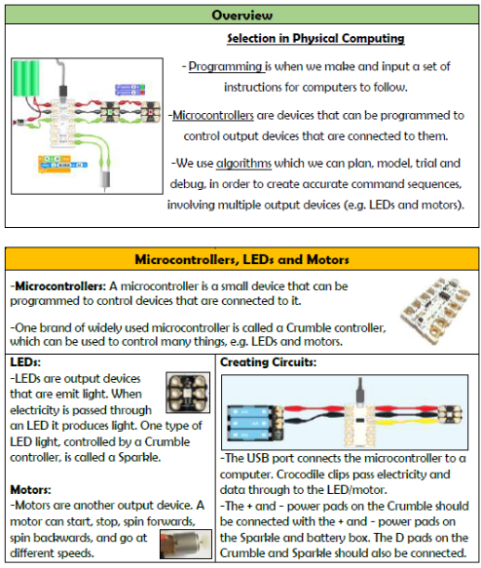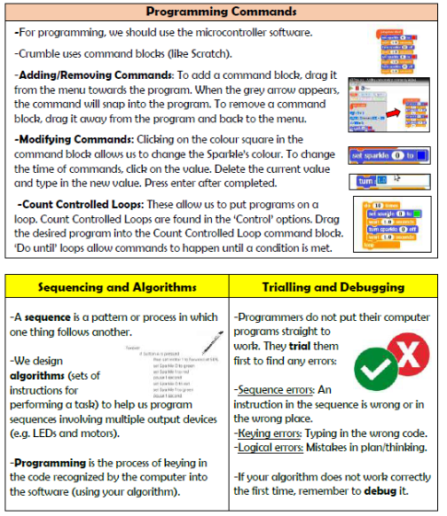

**Programming- Physical Computing**

**Vocabulary**

**Programming, Circuit, Electricity, Micro controller, LED, Code, Algorithm, Motor, Modify, Debugging**

**Knowledge Organiser Year 5**