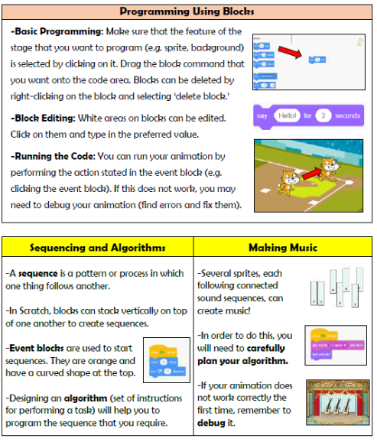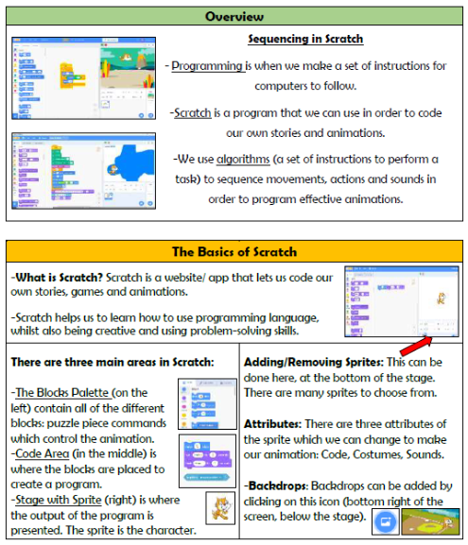

**Vocabulary**

**Programming, Scratch, Blocks, Commands, Code, Sprite, Stage, Costume, Backdrop, Debugging**

**Computing- Programming**

**Knowledge Organiser Year 3**