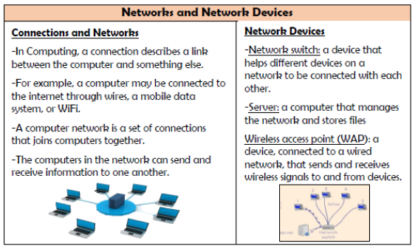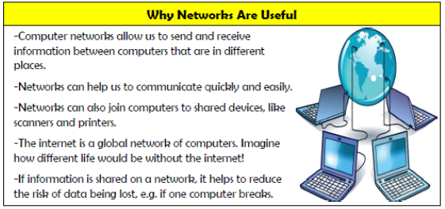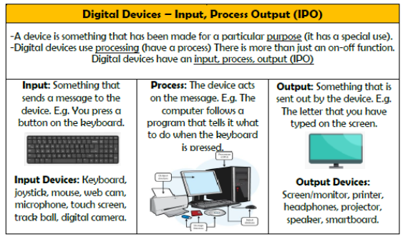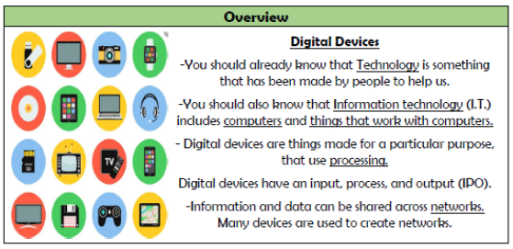

**Computing systems and networks**

**Vocabulary**

**Digital Device, Input, Output, Process, Connection, Network, Network Switch, Server, WAP, E-Safety**

**Knowledge Organiser Year 3**