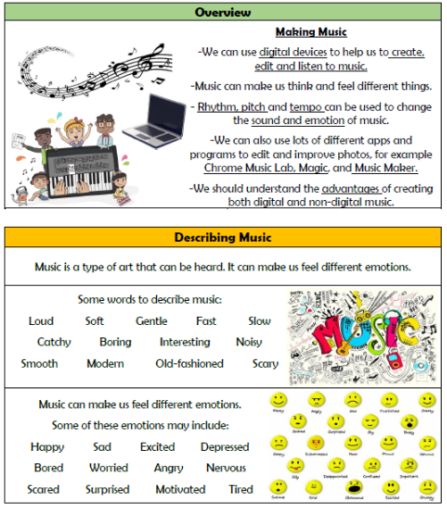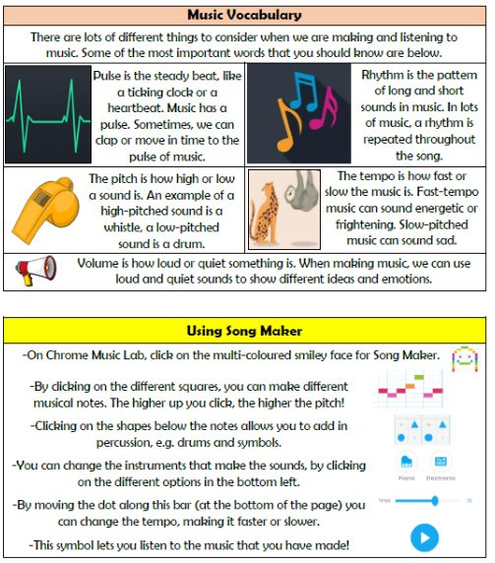

**Creating Media- Making Music**

**Vocabulary**

**Music, Emotions, Pulse, Rhythms, Pattern, Pitch, Tempo, Instrument, Sound, Note**

**Knowledge Organiser Year 2**