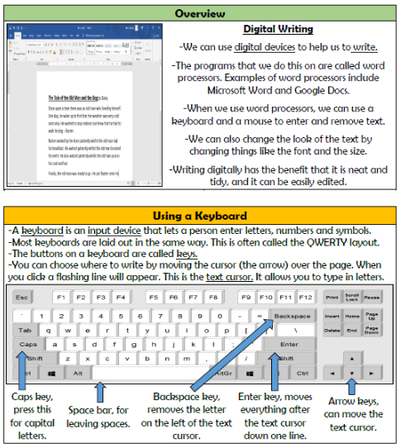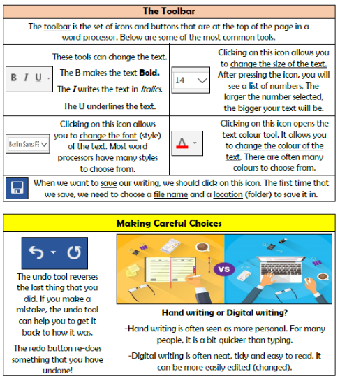

**Creating Media- Digital Writing**

**Knowledge Organiser Year 1**

**Vocabulary**

**Word Processor, Text, Font, Keyboard, Text Cursor, Enter, Spacebar, Toolbar, Font, Icon**